**Sequence models & Attention mechanism**

**LATEST SUBMISSION GRADE**

90%

1.Question 1

Consider using this encoder-decoder model for machine translation.

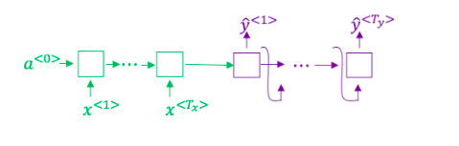

This model is a “conditional language model” in the sense that the encoder portion (shown in green) is modeling the probability of the input sentence x*x*.



True



False

**Correct**

**1 / 1 point**

2.Question 2

In beam search, if you increase the beam width B*B*, which of the following would you expect to be true? Check all that apply.



Beam search will run more slowly.

**Correct**



Beam search will use up more memory.

**Correct**



Beam search will generally find better solutions (i.e. do a better job maximizing *P*(*y*∣*x*))

**Correct**



Beam search will converge after fewer steps.

**1 / 1 point**

3.Question 3

In machine translation, if we carry out beam search without using sentence normalization, the algorithm will tend to output overly short translations.



True



False

**Correct**

**1 / 1 point**

4.Question 4

Suppose you are building a speech recognition system, which uses an RNN model to map from audio clip x*x*to a text transcript y*y*. Your algorithm uses beam search to try to find the value of y*y* that maximizes *P*(*y*∣*x*).

On a dev set example, given an input audio clip, your algorithm outputs the transcript *y*^= “I’m building an A Eye system in Silly con Valley.”, whereas a human gives a much superior transcript y^* =*y*∗= “I’m building an AI system in Silicon Valley.”

According to your model,

*P*(*y*^∣*x*)=1.09∗10−7

*P*(*y*∗∣*x*)=7.21∗10−8

Would you expect increasing the beam width B to help correct this example?



No, because *P*(*y*∗∣*x*)≤*P*(*y*^∣*x*) indicates the error should be attributed to the RNN rather than to the search algorithm.



No, because *P*(*y*∗∣*x*)≤*P*(*y*^∣*x*) indicates the error should be attributed to the search algorithm rather than to the RNN.



Yes, because *P*(*y*∗∣*x*)≤*P*(*y*^∣*x*) indicates the error should be attributed to the RNN rather than to the search algorithm.



Yes, because *P*(*y*∗∣*x*)≤*P*(*y*^∣*x*) indicates the error should be attributed to the search algorithm rather than to the RNN.

**Correct**

**1 / 1 point**

5.Question 5

Continuing the example from Q4, suppose you work on your algorithm for a few more weeks, and now find that for the vast majority of examples on which your algorithm makes a mistake, *P*(*y*∗∣*x*)>*P*(*y*^∣*x*). This suggest you should focus your attention on improving the search algorithm.



True.



False.

**Correct**

**1 / 1 point**

6.Question 6

Consider the attention model for machine translation.

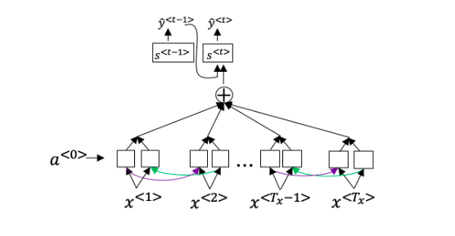

Further, here is the formula for *α*<*t*,*t*′>.

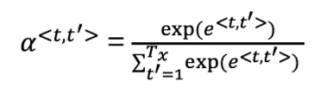

Which of the following statements about *α*<*t*,*t*′> are true? Check all that apply.



We expect *α*<*t*,*t*′> to be generally larger for values of *a*<*t*′> that are highly relevant to the value the network should output for y^{<t>}*y*<*t*>. (Note the indices in the superscripts.)

**Correct**



We expect *α*<*t*,*t*′> to be generally larger for values of a^{<t>}*a*<*t*> that are highly relevant to the value the network should output for *y*<*t*′>. (Note the indices in the superscripts.)



∑*tα*<*t*,*t*′>=1 (Note the summation is over t*t*.)



∑*t*′*α*<*t*,*t*′>=1 (Note the summation is over *t*′.)

**Correct**

**1 / 1 point**

7.Question 7

The network learns where to “pay attention” by learning the values *e*<*t*,*t*′>, which are computed using a small neural network:

We can't replace s^{<t-1>}*s*<*t*−1> with s^{<t>}*s*<*t*> as an input to this neural network. This is because s^{<t>}*s*<*t*> depends on *α*<*t*,*t*′> which in turn depends on *e*<*t*,*t*′>; so at the time we need to evalute this network, we haven’t computed s^{<t>}*s*<*t*> yet.



True



False

**Correct**

**1 / 1 point**

8.Question 8

Compared to the encoder-decoder model shown in Question 1 of this quiz (which does not use an attention mechanism), we expect the attention model to have the greatest advantage when:



The input sequence length T_x*Tx*​ is large.



The input sequence length T_x*Tx*​ is small.

**Correct**

**1 / 1 point**

9.Question 9

Under the CTC model, identical repeated characters not separated by the “blank” character (_) are collapsed. Under the CTC model, what does the following string collapse to?

__c_oo_o_kk___b_ooooo__oo__kkk



cokbok



cookbook



cook book



coookkboooooookkk

**Incorrect**

**0 / 1 point**

10.Question 10

In trigger word detection, x^{<t>}*x*<*t*> is:



Features of the audio (such as spectrogram features) at time t*t*.



The t*t*-th input word, represented as either a one-hot vector or a word embedding.



Whether the trigger word is being said at time t*t*.



Whether someone has just finished saying the trigger word at time t*t*.